The Nautilus DevOps team has been creating a couple of services on AWS cloud. They have been breaking down the migration into smaller tasks, allowing for better control, risk mitigation, and optimization of resources throughout the migration process. Recently they came up with requirements mentioned below. There is an instance named devops-ec2 and an elastic-ip named devops-ec2-eip in us-east-1 region. Attach the devops-ec2-eip elastic-ip to the devops-ec2 instance. Use below given AWS Credentials: (You can run the showcreds command on aws-client host to retrieve these credentials) Console URL https://961888344593.signin.aws.amazon.com/console?region=us-east-1 Username kk_labs_user_511991 Password xY!4H^IUww@C Start Time Sat Dec 06 03:27:10 UTC 2025 End Time Sat Dec 06 04:27:10 UTC 2025 The Nautilus DevOps team has been creating a couple of services on AWS cloud. They have been breaking down the migration into smaller tasks, allowing for better control, risk mitigation, and optimization of resources throughout the migration process.

Recently they came up with requirements mentioned below.

There is an instance named devops-ec2 and an elastic-ip named devops-ec2-eip in us-east-1 region.

Attach the devops-ec2-eip elastic-ip to the devops-ec2 instance. Use below given AWS Credentials: (You

can run the showcreds command on aws-client host to retrieve these credentials) Console URL

https://961888344593.signin.aws.amazon.com/console?region=us-east-1 Username

kk_labs_user_511991 Password xY!4H^IUww@C Start Time Sat Dec 06 03:27:10 UTC 2025 End Time Sat

Dec 06 04:27:10 UTC 2025

Solutions:-

Step-by-Step AWS Console Path
- Log in to the AWS Console
  - Use the provided console URL: AWS Console Login
  - Enter Username: kk_labs_user_511991
  - Enter Password: xY!4H^IUww@C
- Navigate to EC2 Service
  - In the AWS Management Console, go to Services → EC2.
  - Make sure the region is set to us-east-1 (top-right corner).
- Locate the Elastic IP
  - In the left-hand menu, click Allocate Elastic IP address
  - Click on Allocate.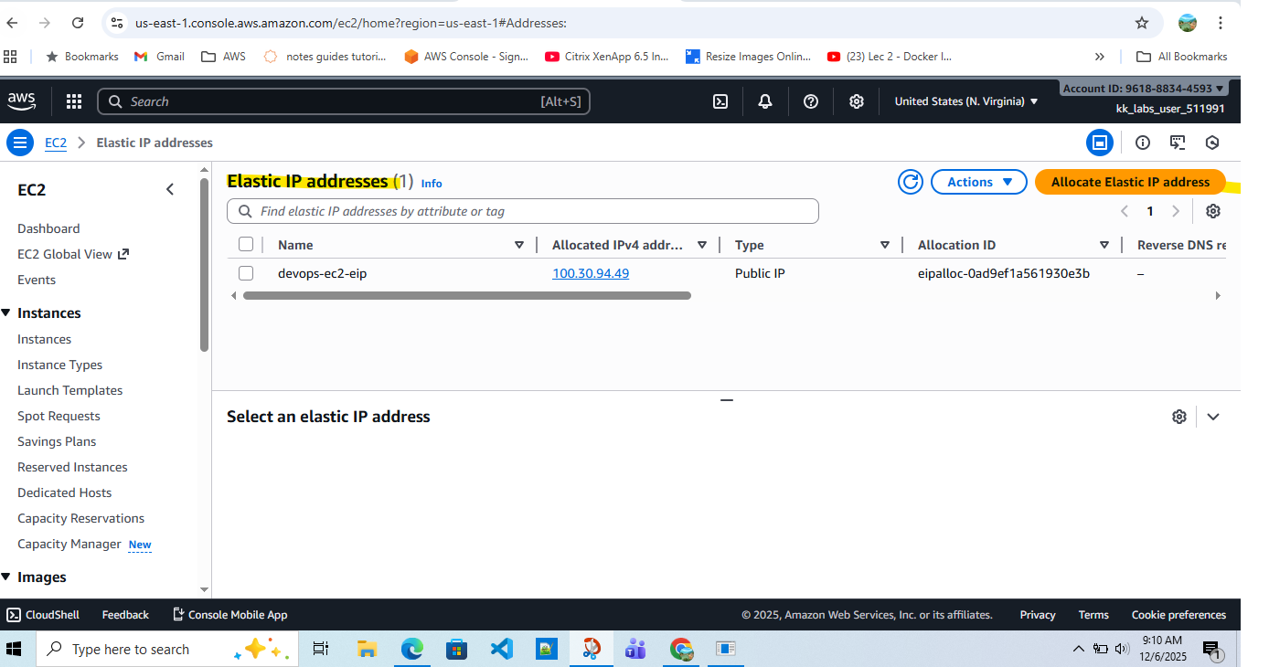

- Associate Elastic IP
  - Click Actions → Associate Elastic IP address.
- Choose the Instance
  - In the Associate Elastic IP dialog:
    - Select Instance as the resource type.
    - From the dropdown, choose the instance named devops-ec2.
    - Leave the private IP field as default (unless multiple private IPs exist).
- Confirm Association
  - Click Associate.
  - The Elastic IP will now be bound to the devops-ec2 instance.
- Verification
  - Go back to Elastic IPs → check that and rename it devops-ec2-eip shows Associated with devops-ec2.
  - Alternatively, under Instances → devops-ec2 → Networking tab, confirm the Elastic IP is listed.
